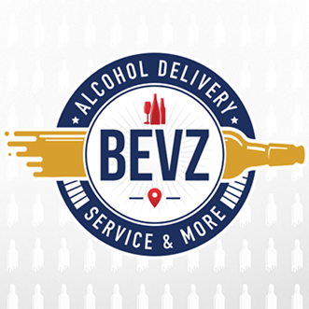
BEVZ RETAILER INSURANCE PROGRAM (BRIP) QUESTIONNAIRE
CONTACT INFORMATION
Business Name
Business Address
Owner Name
Owner Mobile No.
Mailing Address
(if Different from Business Address)
Email Address
- Federal Tax ID Number________________________________________________________________________

- Number of Years in Business___________________________________________________________________

- Current Insurance Carrier and Policy Expiration Date?_____________________________________________

- Estimated Annual Gross Sales? $_______________________________________________________________

- Estimated Value of Inventory/Business Property? $________________________________________________

- Do You Own or Rent the Building? ______RENT _________OWN

- Current Premium? $__________________________________________________________________________
PLEASE COMPLETE AND RETURN TO:
Jesmar Abad jesmar@stearnsandco.com. Phone: (818) 206-4225. Fax: (818) 206-4237

PRESENTED BY

*Premiums of current policies will be prorated and a refund will be issued with no penalties and fees.

